# CAREER GUIDANCE APP FOR STUDENT USING SVM AND DECISION TREE ALGORITHM

## A PROJECT REPORT

***Submitted by***

**TAMIZHSELVAN SL (2116210701284)**

**THARUN VENKAT V (2116210701289)**

**UDHAYACHANDER RJ (2116210701294)**

***in partial fulfillment for the award of the degree of***

**BACHELOR OF ENGINEERING**

***in***

## COMPUTER SCIENCE AND ENGINEERING

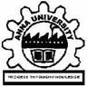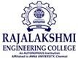

**RAJALAKSHMI ENGINEERING COLLEGE ANNA UNIVERSITY, CHENNAI**

**MAY 2024**

# RAJALAKSHMI ENGINEERING COLLEGE, CHENNAI

**BONAFIDE CERTIFICATE**

Certified that this Thesis titled **“CAREER GUIDANCE APP FOR STUDENTS USING SVM AND DECISSION TREE ALGORITHMS**” is the bonafide work of “**TAMIZHSELVAN SL (2116210701284),THARUNVENKAT V(211621070189),UDHAYACHANDER RJ (2116210701294)”** who carried out the work under my supervision. Certified further that to the best of my knowledge the work reported herein does not form part of any other thesis or dissertation on the basis of which a degree or award was conferred on an earlier occasion on this or any other candidate.

## SIGNATURE

Dr.P.Shanmugam M.tech.,Ph.D.,

## PROJECT COORDINATOR

Professor

Department of Computer Science and Engineering Rajalakshmi Engineering College

Chennai - 602 105

Submitted to Project Viva-Voce Examination held on **\_**

**Internal Examiner External Examine**r

# ABSTRACT

The abstract for the Career Guidance App utilizing Support Vector Machine (SVM) and Decision Tree algorithms encapsulates the essence of the project. The app aims to provide tailored career recommendations for students by analyzing their academic performance, interests, skills, and personality traits. Leveraging SVM and Decision Tree algorithms, the app offers accurate and personalized suggestions to assist students in making well-informed decisions about their future career paths. Through an intuitive user interface, students can input their data, explore various career options, track their progress, and access relevant resources. By harnessing advanced machine learning techniques, the app seeks to bridge the gap between education and career success, empowering students to navigate their professional journeys with confidence and clarity.

# ACKNOWLEDGMENT

First, we thank the almighty god for the successful completion of the project. Our sincere thanks to our chairman **Mr. S. Meganathan B.E., F.I.E.,** for his sincere endeavor in educating us in his premier institution. We would like to express our deep gratitude to our beloved Chairperson **Dr. Thangam Meganathan Ph.D.,** for her enthusiastic motivation which inspired us a lot in completing this project and Vice Chairman **Mr. Abhay Shankar Meganathan B.E., M.S.,** for providing us with the requisite infrastructure.

We also express our sincere gratitude to our college Principal,

**Dr. S. N. Murugesan M.E., PhD.,** and **Dr. P. KUMAR M.E., PhD, Director computing and information science , and Head Of Department of Computer Science and Engineering** and our project coordinator **Dr.P.Shanmugam M.tech.,Ph.D.,** for her encouragement and guiding us throughout the project towards successful completion of this project and to our parents, friends, all faculty members and supporting staffs for their direct and indirect involvement in successful completion of the project for their encouragement and support.

**TAMIZHSELVAN S L**

**THARUN VENKAT V**

**UDHAYACHANDER RJ**

## TABLE OF CONTENTS

|  |  |  |
| --- | --- | --- |
| **CHAPTER NO.** | **TITLE** | **PAGE NO.** |
|  | **ABSTRACT** | **iii** |
|  | **LIST OF TABLES**  **LIST OF FIGURES** | **v**  **vii** |

1. **INTRODUCTION 1**
   1. RESEARCH PROBLEM
   2. PROBLEM STATEMENT
   3. SCOPE OF THE WORK
   4. AIM OF THE PROJECT
   5. OBJECTIVES OF THE PROJECT
   6. RESOURCES
   7. MOTIVATION

## LITERATURE SURVEY 6

* 1. SURVEY
  2. PROPOSED SYSTEM

## SYSTEM DESIGN 9

* 1. GENERAL
  2. SYSTEM ARCHITECTURE DIAGRAM

* 1. SEQUENCE DIAGRAM
  2. DEVELOPMENT ENVIRONMENT
     1. HARDWARE REQUIREMENTS

3.4.2 SOFTWARE REQUIREMENTS

## STUDY & CONCEPTUAL DIAGRAM’S 12

* 1. MTHODOLOGY
  2. MODULE DESCRIPTION

## RESULTS AND DISCUSSIONS 16

* 1. FINAL OUTPUT
  2. RESULT

## CONCLUSION AND SCOPE FOR

**FUTURE ENHANCEMENT 21**

* 1. CONCLUSION
  2. FUTURE ENHANCEMENT

## REFERENCES 26

|  |  |  |
| --- | --- | --- |
|  | **LIST OF FIGURES** |  |
| **FIGURE NO** | **TITLE** | **PAGE NO** |
|  |  |  |
| 3.1 | SYSTEM ARCHITECTURE | 9 |
| 3.2 | SEQUENCE DIAGRAM | 10 |
|  |  |  |
| 5.1 | OUTPUT | 16 |

**CHAPTER 1**

## INTRODUCTION

In today's rapidly evolving educational and professional landscape, students face numerous challenges when it comes to making informed career decisions. The abundance of career paths, the dynamic nature of job markets, and the varying demands of different industries necessitate effective career guidance systems. To address these challenges, this project proposes the development of a Career Guidance App for students, leveraging advanced machine learning techniques, specifically Support Vector Machine (SVM) and Decision Tree algorithms. The app aims to provide personalized career recommendations based on students' unique profiles, including their academic performance, interests, skills, and personality traits.

Effective career guidance is crucial for several reasons. First, it helps students make informed decisions by understanding their strengths and aligning them with suitable career paths. Second, it reduces the anxiety and uncertainty associated with career choices by providing clarity on various career options. Third, students with clear career goals are more motivated to achieve academic and extracurricular excellence. Lastly, it ensures that students' skills and interests are matched with appropriate career opportunities, leading to higher job satisfaction and success.

Machine learning algorithms can significantly enhance the accuracy and personalization of career guidance. By analyzing large datasets of student profiles and career outcomes, machine learning models can identify patterns and predict the most suitable career paths for individual students. Two particularly effective algorithms for this purpose are Support Vector Machine (SVM) and Decision Tree.

Support Vector Machine (SVM) is a powerful supervised learning algorithm used for classification and regression tasks. It works by finding the optimal hyperplane that separates different classes in the feature space. In the context of career guidance, SVM can classify students into different career categories based on their profiles, considering multiple factors simultaneously to distinguish between various career options. On the other hand, the Decision Tree algorithm is a versatile tool for both classification and regression. It models decisions and their possible consequences as a tree-like structure, making it easy to interpret. Decision Trees can map out career pathways based on a series of decisions derived from student data, providing a clear visualization of how different attributes lead to different career recommendations.

The Career Guidance App will feature a comprehensive profile analysis, collecting and analyzing data on students' academic performance, interests, skills, and personality traits. Using SVM and Decision Tree algorithms, the app will provide personalized career suggestions. An intuitive user interface will allow students to explore various career options and understand the rationale behind the recommendations. Additionally, the app will enable students to track their progress and refine their profiles over time for updated recommendations. It will also offer links to relevant resources such as courses, workshops, and career counseling services.

In conclusion, the Career Guidance App utilizing SVM and Decision Tree algorithms represents a significant advancement in the field of educational technology. By harnessing the power of machine learning, the app can deliver highly personalized and accurate career advice, empowering students to navigate their future with confidence. As the app evolves, it holds the potential to become an indispensable tool for students worldwide, bridging the gap between education and career success.

Top of Form

## PROBLEM STATEMENT

Students often face significant challenges in making informed career decisions due to the overwhelming number of career options, rapidly changing job market demands, and the difficulty in aligning their individual skills and interests with suitable career paths. Traditional career counseling methods may not provide the personalized and data-driven guidance needed to navigate these complexities effectively. Therefore, there is a need for a sophisticated, accessible tool that leverages advanced machine learning algorithms to analyze comprehensive student profiles and deliver tailored career recommendations, helping students make well-informed choices about their future careers.

## SCOPE OF THE WORK

The scope of this work involves developing a comprehensive Career Guidance App that utilizes Support Vector Machine (SVM) and Decision Tree algorithms to provide personalized career recommendations for students. The app will collect and analyze data on students' academic performance, interests, skills, and personality traits to generate accurate career suggestions. Key functionalities will include a user-friendly interface for exploring career options, progress tracking, and profile refinement. Additionally, the app will offer resources such as links to relevant courses, workshops, and career counseling services. The project encompasses algorithm development, data collection, user interface design, and integration of supplementary resources to create a holistic career guidance solution.

## AIM AND OBJECTIVES OF THE PROJECT

The aim of this project is to develop a user-friendly Career Guidance App that leverages Support Vector Machine (SVM) and Decision Tree algorithms to provide students with personalized and data-driven career recommendations, helping them make well-informed decisions about their future career paths based on their unique profiles, including academic performance, interests, skills, and personality traits.

**1.5 OBJECTIVES OF THE PROJECT**

The objective of this project is to create an effective Career Guidance App that collects and analyzes students' academic, personal, and interest-related data to offer tailored career advice using SVM and Decision Tree algorithms. The app aims to enhance students' decision-making process by providing clear, actionable career recommendations, along with resources for further learning and development, thereby ensuring students are well-prepared and confident in their career choices.

## RESOURCES

This project has been developed through widespread secondary research of accredited manuscripts, standard papers, business journals, white papers, analysts' information, and conference reviews. Significant resources are required to achieve an efficacious completion of this project.

The following prospectus details a list of resources that will play a primary role in the successful execution of our project:

* + - A properly functioning workstation (PC, laptop, net-books etc.) to carry out desired research and collect relevant content.
    - Unlimited internet access.
    - Machine Learning Frameworks: Tools and libraries for implementing SVM and Decision Tree algorithms, such as Python libraries (scikit-learn, TensorFlow, Keras).

## MOTIVATION

The motivation behind developing the Career Guidance App stems from the recognition of the significant challenges students face in navigating their career paths in today's complex and rapidly changing job market. Traditional career counseling methods often fall short in providing personalized, data-driven guidance tailored to individual students' unique profiles. This can lead to uncertainty, anxiety, and mismatched career choices, which ultimately affect students' academic motivation and future job satisfaction. By leveraging advanced machine learning algorithms such as SVM and Decision Trees, this app aims to bridge the gap between students' aspirations and the dynamic career landscape, empowering them with the tools and insights needed to make informed and confident career decisions. The ultimate goal is to enhance students' educational experiences and career outcomes, contributing to their long-term success and fulfillment.

**CHAPTER 2**

**LITRETURE SURVEY**

(Dahanke Ajay et al.,2022)The paper "An Intelligent Career Guidance System using Machine Learning" from the International Research Journal of Engineering and Technology discusses a system developed to assist students in selecting suitable career paths based on their skills and academic performance. Utilizing machine learning algorithms such as Support Vector Machine (SVM) and Decision Tree, the system analyzes students' interests and their top two subject marks from 12th grade. The goal is to provide accurate career recommendations, thereby reducing the likelihood of students choosing unsuitable career paths and enhancing their chances of success.

(Samruddhi Deshpande et al.,2021)The paper "Prediction of Suitable Career for Students using Machine Learning" published in the International Research Journal of Engineering and Technology (IRJET) outlines a system designed to help students choose suitable careers by evaluating their mental, physical, and psychological aspects, along with academic performance. The system, implemented as both an Android and web application, utilizes machine learning algorithms like Naïve Bayes to predict career paths based on student-provided data. It includes a quiz feature to further assess students' knowledge and interests, aiming to reduce career selection confusion and better align students' strengths with appropriate career choices.

(Ms. Mansi Sonawane et al.,2022)The system leverages machine learning techniques to evaluate students' interests and capabilities through a series of tests, ultimately providing career recommendations. It aims to address the challenge students face in selecting suitable career paths and to prevent career mismatches that can lead to decreased productivity and dissatisfaction. The paper includes a literature review of existing methods and a detailed explanation of the proposed system, its methodology, and its components, such as data collection, preprocessing, and the evaluation process. The system's goal is to provide accurate career guidance by analyzing students' test results and interests, thus enhancing their academic and professional development.

(S. MANIKANDAN et al., 2022) The paper discusses the use of artificial intelligence and deep learning, specifically TensorFlow, to classify and predict students' performance in both academic and non-academic activities. The study analyzes data from 2,500 students, using a combination of academic records and extracurricular activities to forecast future educational outcomes and career paths. The research highlights the accuracy and effectiveness of AI tools in educational data mining, aiming to enhance decision-making processes in student career planning.

(Adán José García et al., 2023) The system utilizes a novel similarity metric to relate profiling, job role matching, and network visualization, enabling students to self-evaluate their skills and understand their relevance to emerging IT jobs. The study emphasizes the need for balancing technical skills with soft skills like communication and teamwork to address the skill gap in the IT job market.

**2.2 PROPOSED SYSTEM :**

The proposed career guidance app for students leverages advanced machine learning techniques, specifically Support Vector Machines (SVM) and Decision Trees, to provide personalized career recommendations. By collecting and analyzing data on students' academic performance, interests, personality traits, and extracurricular activities, the app uses SVM to classify and predict suitable career paths with high accuracy. The Decision Tree algorithm further refines these recommendations by breaking down the decision-making process into an interpretable model, allowing students to understand the rationale behind each suggestion. This hybrid approach ensures that the guidance is both precise and transparent, helping students make informed decisions about their future careers. The app also includes features for continuous feedback and updates, ensuring that the guidance evolves with the students' development and changing interests.

## CHAPTER 3 SYSTEM DESIGN

* 1. **GENERAL**

In this section, we would like to show how the general outline of how all the components end up working when organized and arranged together. It is further represented in the form of a flow chart below.

## SYSTEM ARCHITECTURE DIAGRAM

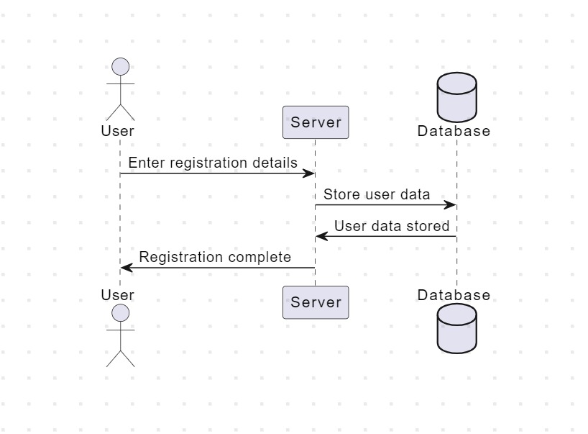

**Fig 3.1: System Architecture**

**3.3 SEQUENCE DIAGRAM :**

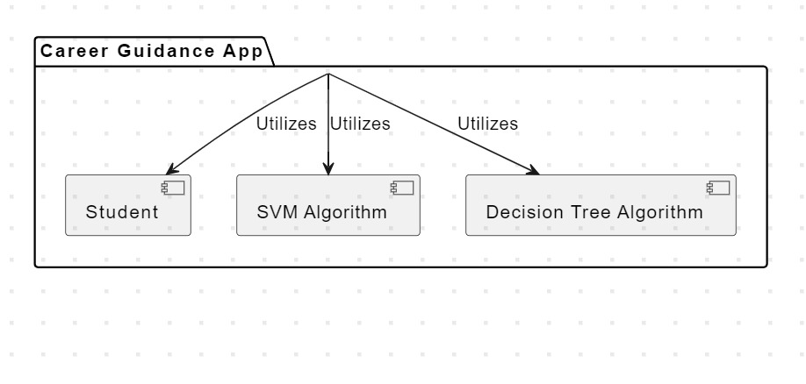

**Fig 3.3 :Sequence Diagram**

## 3.4 DEVELOPMENTAL ENVIRONMENT

* + 1. **HARDWARE REQUIREMENTS**

The hardware requirements may serve as the basis for a contract for the system’s implementation. It should therefore be a complete and consistent specification of the entire system. It is generally used by software engineers as the starting point for the system design.

## Table 3.1 Hardware Requirements

|  |  |
| --- | --- |
| **COMPONENTS** | **SPECIFICATION** |
| PROCESSOR | Intel Core i5 |
| RAM | 8 GB RAM |
| GPU | NVIDIA GeForce GTX 1650 |
| MONITOR | 15” COLOR |
| HARD DISK | 512 GB |
| PROCESSOR SPEED | MINIMUM 1.1 GHz |

* + 1. **SOFTWARE REQUIREMENTS**

The software requirements document is the specifications of the system. It should include both a definition and a specification of requirements. It is a set of what the system should rather be doing than focus on how it should be done. The software requirements provide a basis for creating the software requirements specification. It is useful in estimating the cost, planning team activities, performing tasks, tracking the team, and tracking the team’s progress throughout the development activity.

**Python IDLE, MYSQL,FIGMA**and **chrome** would all be req

**CHAPTER 4**

**PROJECT DESCRIPTION**

## METHODOLODGY

## 

## In The methodology for developing the Career Guidance App using SVM and Decision Tree algorithms follows a structured approach aimed at ensuring the app's effectiveness in providing personalized career recommendations to students.

## Firstly, the process begins with a thorough requirement analysis phase. During this stage, stakeholders' inputs, including students, educators, and career counselors, are gathered to identify the desired features, functionality, and usability of the app. Understanding these requirements is crucial for shaping the development process and ensuring that the app meets the needs of its users.

## Once the requirements are established, the next step involves data collection and preprocessing. Relevant data on students' academic performance, interests, skills, and personality traits are collected from various sources. This data is then cleaned and preprocessed to remove inconsistencies, handle missing values, and ensure compatibility with machine learning algorithms. Data preprocessing plays a critical role in the accuracy and reliability of the career recommendations generated by the app.

## With the data prepared, the focus shifts to algorithm selection and implementation. Suitable machine learning algorithms, such as SVM and Decision Tree, are chosen based on the nature of the problem and the characteristics of the data. These algorithms are implemented using appropriate libraries, such as scikit-learn in Python, and are fine-tuned to optimize performance. Algorithm selection and implementation are key factors in the app's ability to generate accurate and relevant career suggestions for students.

## Following algorithm implementation, the next stage involves model training and validation. The dataset is split into training and testing sets, and the machine learning models are trained on the training data. The performance of the models is then validated using cross-validation techniques, with metrics such as accuracy, precision, recall, and F1-score used to assess their effectiveness. Rigorous testing and validation ensure that the models can reliably provide meaningful career recommendations to students.

## Simultaneously, development of the user interface and backend of the app takes place. A user-friendly interface is designed and developed to allow students to input their data, view career recommendations, track progress, and access resources. The backend of the app is built to handle data processing, algorithm execution, and communication with the frontend. Functionalities such as user authentication, data storage, retrieval, and API integration with external resources are implemented to ensure a seamless user experience.

## Once the frontend, backend, and machine learning models are developed, the focus shifts to integration and testing. The various components of the app are integrated into a cohesive system, and thorough testing is conducted to identify and resolve any bugs or issues. This ensures that the app functions as intended and provides accurate and reliable career guidance to students.

## Finally, the app is deployed on a cloud platform for public access. Continuous monitoring of the app's performance, user feedback, and analytics is conducted to make ongoing improvements. Regular maintenance and support are provided to address any issues and update features as needed, ensuring that the Career Guidance App remains effective and valuable for students in making informed career decisions.

## MODULE DESCRIPTION

The Career Guidance App is comprised of several interconnected modules, each serving a specific function to facilitate the delivery of personalized career recommendations to students. The Data Collection Module is responsible for gathering relevant information from students, including academic performance, interests, skills, and personality traits. Once collected, the data is processed and cleaned within the Data Preprocessing Module to ensure accuracy and compatibility with machine learning algorithms. The Machine Learning Module utilizes Support Vector Machine (SVM) and Decision Tree algorithms to analyze the student data and generate personalized career recommendations based on patterns and correlations identified within the dataset. These recommendations are then presented to users through the User Interface Module, where students can input their data, view career suggestions, track their progress, and access additional resources. The Backend Module manages the communication between the frontend interface and the machine learning algorithms, handling tasks such as data processing, storage, retrieval, and API integration with external resources. Finally, the Deployment and Maintenance Module oversees the deployment of the app on a cloud platform for public access and ensures ongoing maintenance and support to address any issues, update features, and enhance the overall user experience. Together, these modules form a cohesive system designed to empower students with the tools and insights needed to make informed and confident decisions about their future career paths.

## CHAPTER 5

**RESULTS AND DISCUSSIONS**

## OUTPUT

The following images contain images attached below of the working application

## C:\Users\USER\AppData\Local\Packages\5319275A.WhatsAppDesktop_cv1g1gvanyjgm\TempState\BFCE8236677A94E0C332929D9755C756\WhatsApp Image 2024-05-19 at 17.21.05_5e06995a.jpg

## Fig 5.1a: Output

## C:\Users\USER\AppData\Local\Packages\5319275A.WhatsAppDesktop_cv1g1gvanyjgm\TempState\52E84C2AE14BA4A5898AA0D2A857C4D5\WhatsApp Image 2024-05-19 at 17.21.54_d81d24b5.jpg

## Fig 5.1b: Output

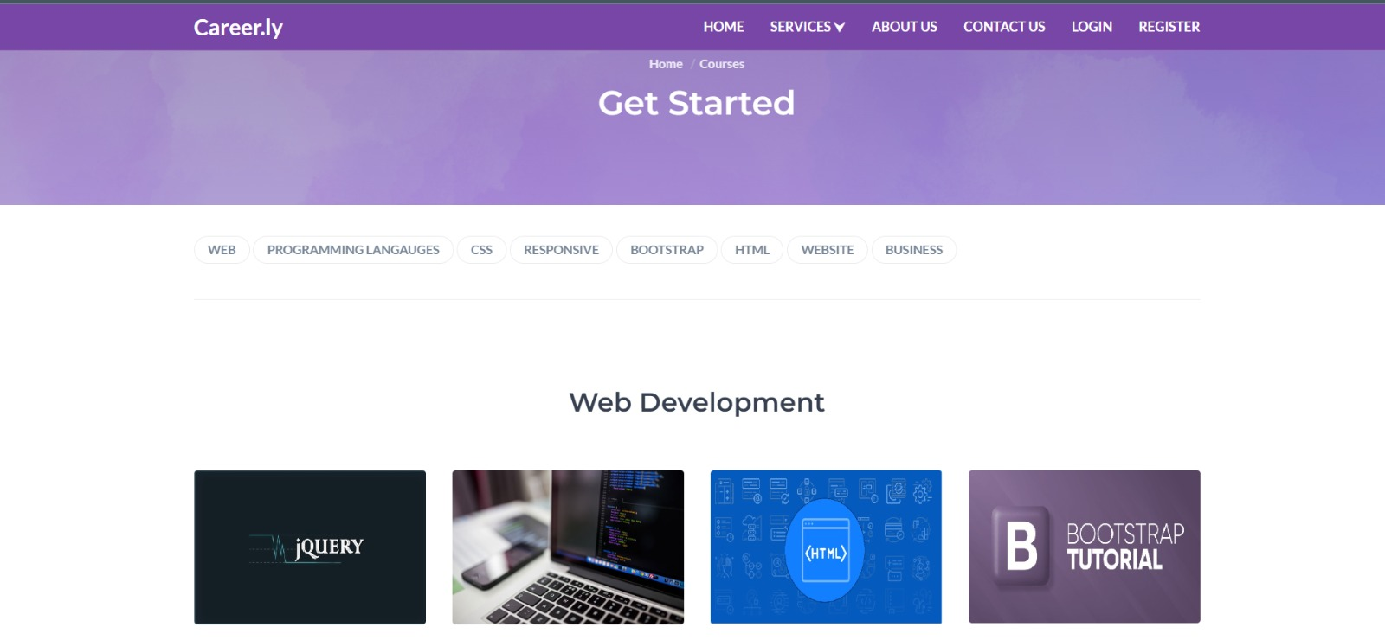

## Fig 5.1c: Output

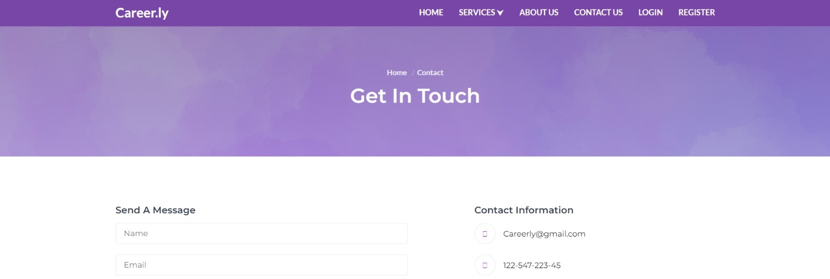

**Fig 5.1d: Output**

* 1. **RESULT**

The result of developing the Career Guidance App using SVM and Decision Tree algorithms is a comprehensive and user-friendly platform that provides students with personalized career recommendations based on their unique profiles. By leveraging advanced machine learning techniques, the app accurately analyzes student data, including academic performance, interests, skills, and personality traits, to generate actionable insights and suggestions for future career paths. The app's intuitive user interface allows students to input their data, explore career options, track their progress, and access relevant resources, empowering them to make informed decisions about their educational and professional trajectories. Through rigorous testing and validation, the app ensures the reliability and accuracy of its recommendations, providing students with valuable guidance and support as they navigate their career journeys. Overall, the result is an innovative and impactful solution that addresses the challenges students face in making meaningful career decisions, ultimately helping them achieve success and fulfillment in their chosen fields.

## CHAPTER 6

**CONCLUSION AND FUTURE ENHANCEMENT**

## 6.1 CONCLUSION

In conclusion, the development of the Career Guidance App using Support Vector Machine (SVM) and Decision Tree algorithms represents a significant step forward in empowering students to make informed and confident decisions about their future career paths. By harnessing the power of advanced machine learning techniques, the app provides personalized career recommendations based on comprehensive analysis of students' academic performance, interests, skills, and personality traits. Its intuitive user interface, coupled with rigorous testing and validation, ensures the reliability and accuracy of its suggestions, while also offering students access to additional resources for further exploration and development. Through this innovative solution, students are equipped with the tools and insights needed to navigate the complexities of the modern job market and pursue careers that align with their aspirations and strengths. Ultimately, the Career Guidance App serves as a valuable asset in guiding students towards fulfilling and successful professional endeavors, thereby contributing to their long-term growth and happiness.

## FUTURE ENHANCEMENT

In the future, several enhancements could further improve the functionality and effectiveness of the Career Guidance App:

**1**.Integration of Additional Algorithms: While SVM and Decision Tree algorithms provide valuable insights, integrating additional machine learning algorithms such as Random Forest, Neural Networks, or Ensemble methods could enhance the accuracy and robustness of career recommendations.

**2**.Incorporation of Natural Language Processing (NLP): Integrating NLP techniques could enable the app to analyze textual data such as resumes, cover letters, or job descriptions, providing more comprehensive insights into students' qualifications and aligning them with suitable career opportunities.

**3.**Dynamic Updating of Recommendations: Implementing a mechanism to continuously update and refine career recommendations based on real-time data could ensure that suggestions remain relevant and reflective of evolving job market trends and individual preferences.

**APPENDIX**

**SOURCE CODE:**

import pandas as pd

import numpy as np

import pickle

career = pd.read\_csv('dataset9000.data', header = None)

#np.dtype('float64')

X = np.array(career.iloc[:, 0:17]) #X is skills

print(X)

y = np.array(career.iloc[:, 17]) #Y is Roles

print("hi")

print(y)

## attribute to return the column labels of the given Dataframe

career.columns = ["Database Fundamentals","Computer Architecture","Distributed Computing Systems",

"Cyber Security","Networking","Development","Programming Skills","Project Management",

"Computer Forensics Fundamentals","Technical Communication","AI ML","Software Engineering","Business Analysis",

"Communication skills","Data Science","Troubleshooting skills","Graphics Designing","Roles"]

career.dropna(how ='all', inplace = True)

#print("career.dropna(how ='all', inplace = True)",career.dropna(how ='all', inplace = True))

career.head()

## splitting the data into training and test sets

from sklearn.model\_selection import train\_test\_split

X\_train, X\_test, y\_train, y\_test = train\_test\_split(X, y,test\_size = 0.3, random\_state = 524)

from sklearn.neighbors import KNeighborsClassifier

from sklearn import metrics

scores = {}

knn = KNeighborsClassifier(n\_neighbors=5)

knn.fit(X\_train, y\_train)

print('X\_train',X\_train)

print('y\_train',y\_train)

y\_pred = knn.predict(X\_test)

print('y\_pred',y\_pred)

scores[5] = metrics.accuracy\_score(y\_test, y\_pred)

print('Accuracy=',scores[5]\*100)

pickle.dump(knn, open('careerlast.pkl','wb'))

print('test file created')

## REFERENCES

* 1. **An Intelligent Career Guidance System using Machine Learning**

D Ajay, S Nilesh, D Anirudh, S Huzaif, P v Nagare - 2022 - academia.edu

**[2] Prediction of Suitable Career for Students using Machine Learning**

S Deshpande, P Gupta, N Singh-2021

**[3] Learning Techniques based model for User Interest and Career**

**prediction** MM Sonawane, MR Raut, MR Sonawane, MS Naik -2022

**[4] Evaluation of students' performance in educational sciences a**

**prediction of future development using tensorflow**S Manikandan, M

Chinnadurai – 2020

**[5] A career guidance system for assessing student skills using machine**

**learning and network visualization** A José-García, A Sneyd, A Melro, A

Ollagnier-2023

**[6] A Career guidance mobile Application based on personality**

Too,Faith, Strathmore University-2017

**[7] An Improved Grey Wolf Optimization Strategy Enhanced SVM and**

**Its Application in Predicting the Second Major,** Yan Wei, NiNi, Dayou

Liu,Yan Wei et al-2017

**[8] Smart Career Guidance App**, Dr.Sheik Faritha BegumInternational Journal of

Emerging Technology in Computer Science & Electronics-2022

**[9] Application of decision tree algorithm mining model in career planning**

**goal simulation,**Mr.Ruili Shang Applied mathematics and non linear

science-2022

**[10] Prediction of future career path using different machine learning**

**models** S Sengupta, A Banerjee, S Chakrabarti - … Technologies in Data

Mining**-**2021